Structure of Matter

Compounds and Molecules

All forms of matter (rocks, tables, sugar, etc.) have similarities and differences.

Those similarities and differences are partly because of how the atom or ions are joined together.

Chemical Bonds:

Remember…a compound is made of 2 or more elements that are chemically combined.

- atoms are connected chemically by bonds.

Chemical Bonds: the forces that hold atoms or ions in a compound together.

Chemical Structure:

The chemical formula tells us what atoms make up a compound.

Ex. H₂O = 2 hydrogens and 1 oxygen

But it doesn’t tell us what the molecules look like or how the atoms are connected.

The structure of a compound is like the structure of a building.

- the structure of a building is the way its parts are put together.

- the structure of a compound shows the way the atoms are bonded.

  - Chemical structure can be shown with different models. (just like the blueprints show the structure of a building.)

Different types of models show different aspects of the compound.

Types of Models: (Molecular Models)

- Ball-and-stick

- used to show bond lengths and bond angles.

- Atom = Ball
Bond = Stick

Bond Length: distance between the nuclei of two atoms.

Bond Angle: angle formed by 2 bonds to the same atom.

• the bond angle tells which way the atoms points.

- Ball-and-stick models help understand how the atoms in a molecule are arranged.

Ex.

- Structural Formulas (lazy chemist version)

- also show the structure of a molecule.

- Structural formula uses chemical symbol to represent the atoms.

Ex.
- Space-filling model

- shows the space taken up by each of the atoms in a compound.

- Shows relative sizes of atoms in a compound.

EX.

Bonds are flexible.

- bonds can bend, stretch, and rotate without breaking.

- A more accurate representation of the ball-and-stick model would be to represent the bonds with springs rather than sticks.

- See fig. 3 page 179
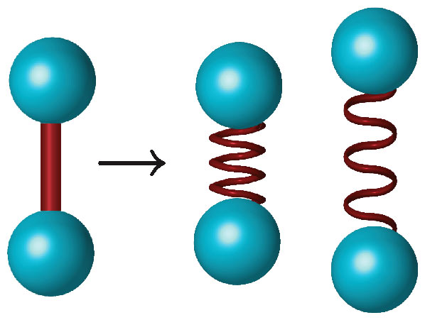

How does the structure affect properties?

The chemical structure of a compound determines the properties of the compound.

Compounds can be found in several different forms.

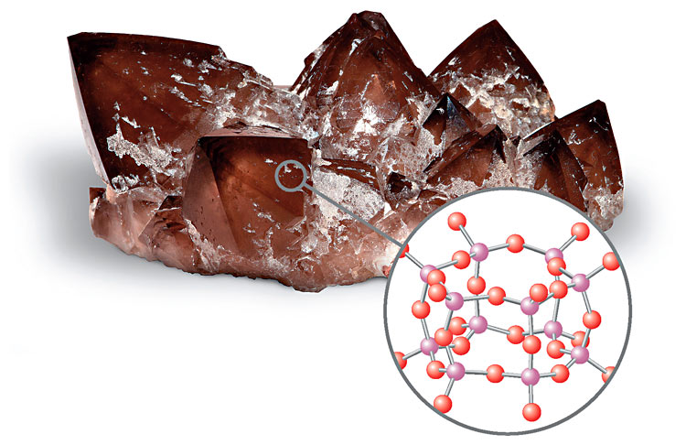
- Large Networks of bonded ATOMS

Ex. Quartz

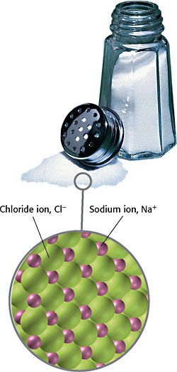
- Large Networks of bonded positive and negative IONS.

Ex. NaCl

- Separate Molecules
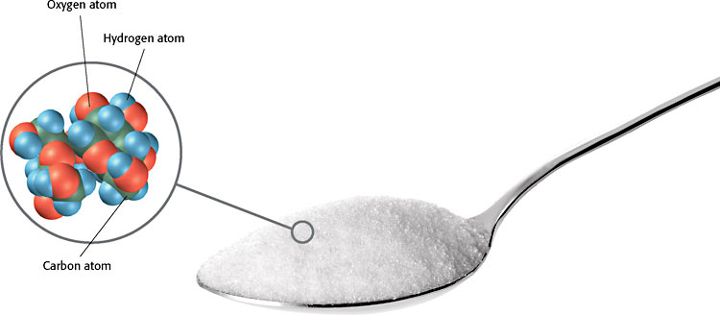
Ex. Water or Sugar

- compounds with network structures are strong solids.

  - The strong bonds in these compounds are very hard to break and cause the substance to have very high melting and boiling points.

- Some compounds are made of molecules .

  - In these compounds the attraction between molecules is very small compared to the attraction between the elements in the compound.

Ex. Attraction between molecules of sugar is much smaller that the attraction between the Carbon, Hydrogen, and Oxygen atoms that make up the molecule.

  - Because these molecules have weaker attractions between them they tend to spread out more and take up more space.

  - The strength of attraction between molecules differs between substances.

    - This is why substances have different properties , such as boiling points and melting points.
So…we’ve talked about the differences between the attractions between molecules and between individual atoms.

There’s one more special type of attraction to be discussed…..Hydrogen bonds!

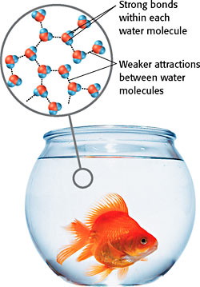
Hydrogen Bonds- the weak attraction between the molecules of water.

- these aren’t as strong as the bonds holding the molecule together, but they do influence the properties of water.

Ionic and Covalent Bonding

Why do chemical bonds form?

Atoms bond when their valence electrons interact.

- remember…only the s and p orbital valence electrons matter when determining the stability of an atom.

- generally, atoms join to form bonds so that each atom has a stable electron configuration.

(remember the electron structures will look like noble gases when they are stable.)

There are 2 basic kinds of chemical bonds:

- Ionic Bonds
- Covalent Bonds

Ionic compounds Co
 | Ionic compounds | Covalent compounds
Structure | network of bonded ions | molecules
Valence electrons | transferred (Given Away) | shared
Electrical conductivity | good (when melted or dissolved) | poor
State at room temperature | solid | solid, liquid, or gas
Melting and boiling points | generally high | generally low

lent compounds
Ionic Bonds:

Atoms of metals form positive charged ions. (cations)
Atoms of nonmetals form negative ions. (anions)

Ionic Bonds form between 2 oppositely charged ions.

Characteristics of Ionic Bonds:

- Form by the transfer of electrons.

- one atom gains electrons and the other atom loses electrons.
Ex. Na & Cl

- The result is a positive ion and a negative ion.
Ex. Na⁺ & Cl⁻

- Each positive ion attracts several negative ions and each negative ion attracts several positive ions.
- Eventually a large network of both positive and negative ions forms.

- Ionic compounds are networks, not molecules.

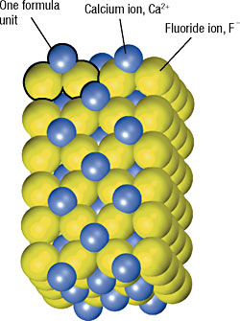
- there is no individual NaCl molecule… every Na⁺ ion is surrounded by 6 Cl⁻ ions.

- Therefore chemists talk about the smallest ratio of atoms to determine the chemical formula.

Ex. NaCl means that overall in the network there for every Na⁺ there is one Cl⁻.

- Ionic compounds can conduct electricity when melted or dissolved.

- this occurs because when the compound is dissolved it moves freely in the liquid, not locked into position like in water.

Covalent Bonds

Compounds that are made of molecules (ex. Sugar and water) have covalent bonds.

Atoms joined by covalent bonds share electrons.

- covalent bonds typically form between nonmetal atoms.

Characteristics of Covalent Bonds:

- covalent compounds can be solids, liquids, or gases.

- Most have low melting points. (below 300°C)

- Molecules move freely when dissolved or melted.

- most do not conduct electricity. (because they aren’t charged)

- atoms may share more than 1 pair of electrons.

** See Notes on Lewis Structures**

  - the more electrons shared between atoms the stronger the bond is.

  - Each bond represents 2 e⁻‘s.

Single bond 2 e⁻
Double Bond 4 e⁻ (stronger than single)
Triple Bond 6 e⁻ (stronger than double)

- Atoms don’t always share electrons equally.
- sometimes shared electrons are pulled more towards one atom than the other in the bond.

Metallic Bonds

Metals are flexible and conduct electric current well because their atoms and electrons can move freely throughout the metals structure.

The atoms in a metal form metallic bonds.

Metallic Bonds are the attraction between an atoms nucleus and a neighboring atom’s electrons.

  - This attraction packs the atoms closer together.

  - Outer energy levels overlap

  - Electrons begin to move between atoms.

Polyatomic Ions

Until now we have talked about compounds that have ionic or covalent bonds only.

Some compounds form both!

- these are polyatomic ions, which are groups of covalently bonded atoms that have a positive or negative charge as a group.

- Polyatomic ions act as a single unit in a compound, just as ions that consist of a single atom do.

There are lots of polyatomic ions.

- They can be positively or negatively charged.

- Positive and negative polyatomic ions can combine to form compounds just like individual ions can.

- Parentheses group the atoms of a polyatomic ion together when a compound has more than one of them.
Ion NameIon Formula¹
Ion Name | Ion Formula
Nitrate | NO₃⁻¹
Nitrite | NO₂⁻¹
Phosphate | PO₄⁻³
Sulfate | SO₄⁻²
Ammonium | NH₄⁺¹
Hypochlorite | ClO⁻¹
Compound and Formula Names
Ion Name | Ion Formula
Acetate | C₂H₃O₂⁻¹ or CH₃CO₂⁻¹
Carbonate | CO₃⁻²
Chlorate | ClO₃⁻¹
Cyanide | CN⁻¹
Hydroxide | OH⁻¹

Just like elements have names that make them unique from other elements…so do compounds.

- The names of the compounds come from the elements that make them up

Naming Ionic Compounds:

Remember…ionic compounds are formed by the strong attractions between cations (positive) and anions (negative).

- Both ions are important to the structure of the compound.

- The names of ionic compounds consist of the ions they are made of.

Naming Cations:

In most cases the name of the cation is the same as the name of the element.

- This is typically for elements that you can predict the charge for from the periodic table and will always form the same charge ions

EX. Na = Sodium
Na⁺ = Sodium ion
Ca = Calcium
Ca²⁺ = Calcium ion

Naming Anions:

Names of anions are usually altered versions of the element name.

• The endings are changed.

Element | Ion | Ion charge
Fluorine, F | fluoride ion, F⁻ | 1−
Chlorine, Cl | chloride ion, Cl⁻ | 1−
Bromine, Br | bromide ion, Br⁻ | 1−
Iodine, I | iodide ion, I⁻ | 1−
Oxygen, O | oxide ion, O²⁻ | 2−
Sulfur, S | sulfide ion, S²⁻ | 2−
Nitrogen, N | nitride ion, N³⁻ | 3−
- To name the compound just combine the name of the cation and the name of the anion.
EX. NaF Sodium Fluoride
CaO Calcium Oxide
LiBr Lithium Bromide

Ionic compounds must have an overall charge of zero.

- so…if the charge of the cation and the anion are different…the ratio of ions will not be 1:1

- Find the least common multiple of charges to produce an overall charge of zero for the compound.
Swap and Drop the Charges! (
Then reduce if needed.
EX. Al⁺³ & O⁻²

Least common multiple between 2 & 3 is 6…. Use the factors to determine the subscripts.

So…the chemical formula is: Al₂O₃

What about elements that form multiple ions?

Transition metals form lots of different charged ions.

Ex. Iron commonly forms Fe⁺² and Fe⁺³

So…when iron combines with oxygen…there are a few different possibilities:

Fe⁺² + O⁻² => FeO (iron oxide)

Fe⁺³ + O⁻² => Fe₂O₃ (iron oxide)

How do we differentiate between these two different compounds? (Since they will have different properties?)

Easy…include the charge of the cation as a Roman numeral in parentheses in the compound name.

Ex. FeO => Iron(II) Oxide
Fe₂O₃ => Iron(III) Oxide

So…how is the charge of a transition metal determined since they aren’t always the same?

- look at the anion…it will be something you know and you can use it to determine the charge.

Ex. CrCl₃

Chlorine has a charge of -1

So… 3 Cl⁻¹ = -3

Therefore, Chromium must be +3 to balance out.

So the name would be Chromium (III) Chloride.

